Design of Experiment (DoE) Approach to Increase Response Rate of E-mail Marketing Program
Name
Institution

Design of Experiment (DoE) Approach to Increase Response Rate of E-mail Marketing Program
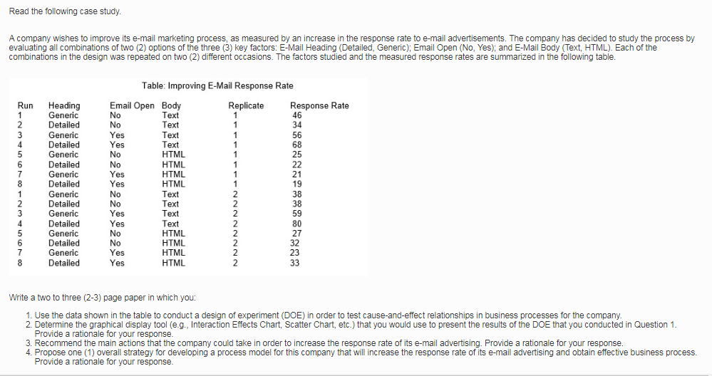
Question 1: Assessing the Cause-and-Effect Relationship
Table 1: Statistical Combination of two-Options of the Key Factors
Run | Heading (x1) | Email Open(x2) | Body(x3) | x1 x2 | x1x3 | x2x3 | x1x2x3 | R Rate 1 | R Rate 2 | Ave RR | SD RR
1 | Generic(-) | No(-) | Text(-) | + | + | + | - | 46 | 38 | 42 | 5.656854
2 | Detailed(+) | No(-) | Text(-) | - | - | + | + | 34 | 38 | 36 | 2.828427
3 | Generic(-) | Yes(+) | Text(-) | - | + | - | + | 56 | 59 | 57.5 | 2.12132
4 | Detailed(+) | Yes(+) | Text(-) | + | - | - | - | 68 | 80 | 74 | 8.485281
5 | Generic (-) | No(-) | HTML(+) | + | - | - | + | 25 | 27 | 26 | 1.414214
6 | Detailed(+) | No(-) | HTML(+) | - | + | - | - | 22 | 32 | 27 | 7.071068
7 | Generic(-) | Yes(+) | HTML(+) | - | - | + | - | 21 | 23 | 22 | 1.414214
8 | Detailed(+) | Yes(+) | HTML(+) | + | + | + | + | 19 | 33 | 26 | 9.899495
sum+ | 163 | 179.5 | 101 | 168 | 152.5 | 126 | 145.5
sum- | 147.5 | 131 | 209.5 | 143 | 158 | 185 | 165
ave + | 40.75 | 44.875 | 25.25 | 42 | 38.13 | 31.5 | 36.375
ave- | 36.875 | 32.75 | 52.375 | 35.6 | 39.5 | 46.1 | 41.25
effect | 3.875 | 12.125 | -27.125 | 6.38 | -1.38 | -15 | -4.875
b0 = | 77.625
b1= | 1.9375
b2= | 6.0625
b3= | -13.5625
b4= | 3.1875
b5 = | -0.6875
b6= | -7.3125
b7= | -2.4375
Regression Model is
y = b0 + b1x1 + b2x2 + b3x3 + b4x1x2 + b5x1x3 + b6x2x3 + b7 x1 x2 x3
y = 77.625 + 1.9375 x1 + 6.0625 X2 -13.5625 x3 + 3.1875 x1 x2 -0.6875x1x3 -7.3125 x2x3 - 2.4375 x1 x3 x3

A Design of Experiment analysis utilized a replication process to estimate the amount of errors involved in a particular combination of options. A replication approach merits because it involves undertaking a similar test in several occasions to enhance the reliability of the outcomes (Sundararajan, 2018). Therefore, three key factors considered to influence the consumers’ response to an email-marketing promotion include the Email Heading, Email Open, and Email Body. The three key factors comprised of a possible options that the assessor would engage to yield the highest possible response. Specifically, the two options for the Email Heading were ‘Detailed-option’ or ‘Genetic Heading’ while the Email Open factor entailed a ‘Yes-option’ or ‘No-option. The use of a ‘Text-Option’ and ‘HTML-Option’ were the available options to bolster reliability of an e-mail marketing strategy. The Design of Experiment employed a two-level factorial design because of the versatility, simplicity, and ability to incorporate several input-factors.
Therefore, table 1 above reveals the outcomes of the combination of several options. Each combination yielded unique response rate during the initial run and the replication procedure. The most effective combination resulted in an average response rate of 74. Therefore, the company can maximize on the email-marketing strategy by implementing a detailed heading with an open email (yes) and text-based body. The Analysis of Variance (ANOVA) was critical toward quantifying the existence of a cause-and-effect relationship involving the strategic combination of options.
The regression model of y =77.625 + 1.9375X₁ + 6.0625X₂ -13.5625X₃ + 3.1875X₁X₂ -0.6875X₁X₃ -7.3125X₂X₃ - 2.4375X₁X₂X₃ reveals the relationship of the combination selected to achieve the highest response rate from the e-mail marketing process. Therefore, a scatter chart plotted using the regression model Y= -2.4375X₁X₂X₃ +77.625 demonstrate the existence of a causation relationship involving the Email Heading, Email Open, and Email Body factors.
Question 2: Rational Graphical Display Tool
Statisticians utilize several tools to present the outcomes of an experiment. A scatter chart is a reliable graphical representation model to disseminate information about the variation in a relationship that involves several constructs (Nelson, 2014). The scatterplot is an ideal graphical tool to presents the outcomes of Design of Experiment procedure that utilizes key factors, which include Email Heading, Email Open, and Email Body, and subsequent combination of the strategic options.
Figure 1: Scatter Chart

The scatter chart above merits because it incorporate several outcomes of an experiment. For instance, the scatter chart above represents the outcomes of a Design of Experiment involving two critical factors and eight combination options. Therefore, the most effective combination from the experiment from the chart involves (++-), which implies an email marketing program that embraces a detailed heading, open, and text-based options. Besides, a scatterplot facilitates an assessor to extrapolate the line-of-best-fit analysis. The case above reveals the reasonable combination in the second and fourth experimental runs.
Question 3: Recommendation
The email advertising is a strategic program that can enhance positive responses from the clients. However, different combination of options yield varied outcomes as revealed in figure 1 above. The most effective combination of the email-advertising program entails a detailed heading to facilitate customization of a promotional message. Second, the profitable email advertisement should utilize a text-based body to influence the compatibility of particular promotion message that the company disseminates to its clients. The Design of Experiment approach revealed the highest average-response rate of .74, which represents the most-profitable combination of available options.
Question 4: Overall Strategy
A business entity faces continuous challenges that require implementation of effective strategies to optimize the inputs parameters. Therefore, it is recommendable that the business acquires statistical capabilities to facilitate regular assessment of the existing cause-and-effect relationships during decision-making process. In particular, familiarizing with a Design of Experience procedure is a strategic recommendation because of the ability to increase efficiency in decision-making (Gadbury, G. & Schreuder, 2002). Therefore, designing an email advertisement that incorporates a detailed heading, open, and text-based content can trigger significant responses from the clients. Equally, the ability to combine the three factors that include Email Heading, Email Open, and Email Body can bolster effectiveness in business process because it demonstrates the capacity to optimize the existing input-resources.

References
Gadbury, G. & Schreuder, H. (2002). Cause-Effect relationships in analytical surveys:An illustration of statistical issues, University of Missouri
Nelson, S. (2014). Excel data analysis for dummies, John Wiley & Sons
Sundararajan, K. (2018). “Design of Experiment: A primer,” I-Six Sigma. Retrieved from www.isixsigma.com/tools-templates/design-of-experiments-doe/design-experiments-␓-primer [Accessed May 23, 2013]

